**Experiment Procedure Documentation**

**Introduction**

This document captures the instructions to run the simulation.

**Instructions**

1. To run the experiment, simply run the experiment.html file by clicking on it and the experiment will open in the browser.
2. To run the experiment of weirs, click “start” button.

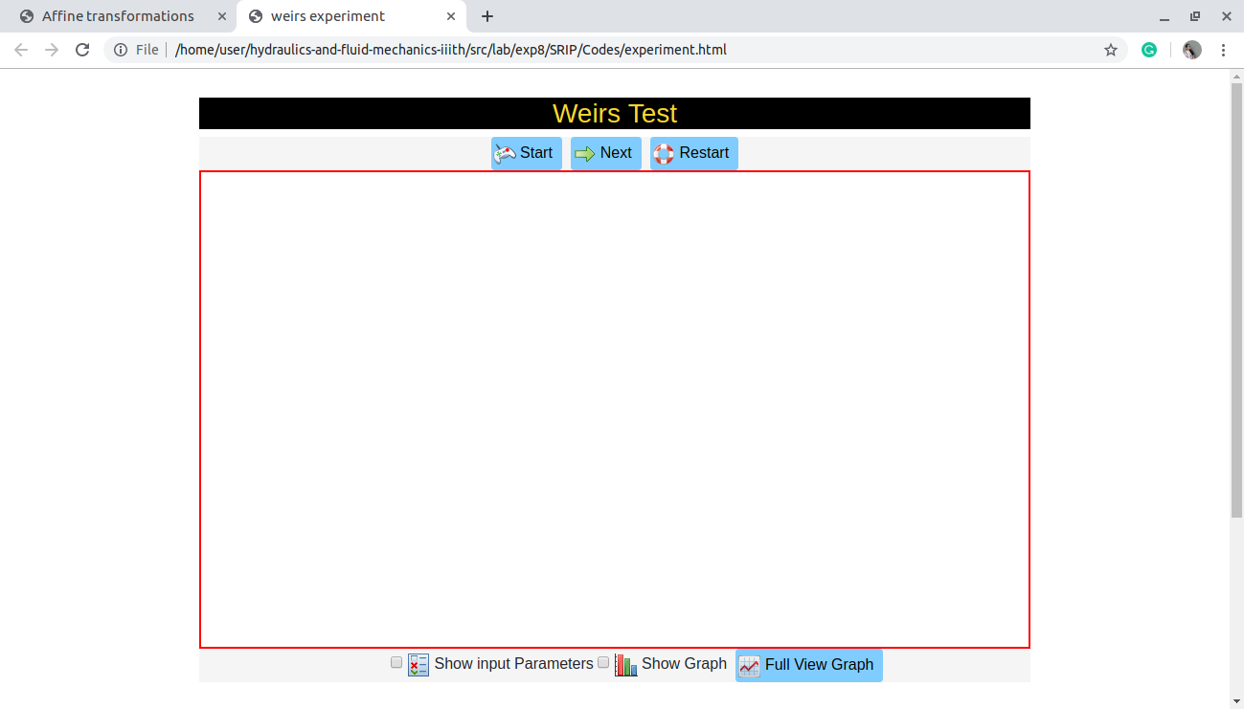

1. Observe the simulation .
2. “stop” button is to stop simulation in between.

“restart” to reload page.

1. “next” button is used to onclick button to observe each step.

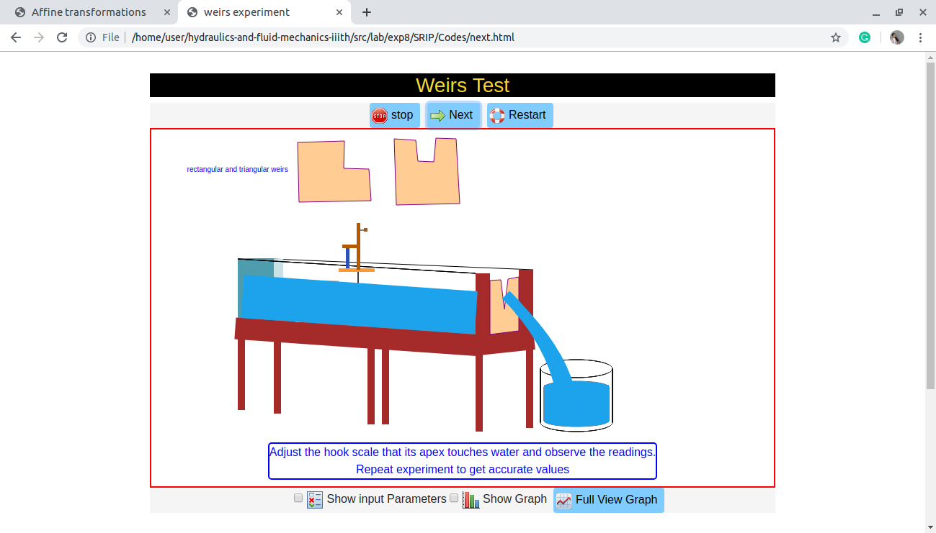

1. input paremters can be adjusted enabling checkbox “show input parameters”
2. 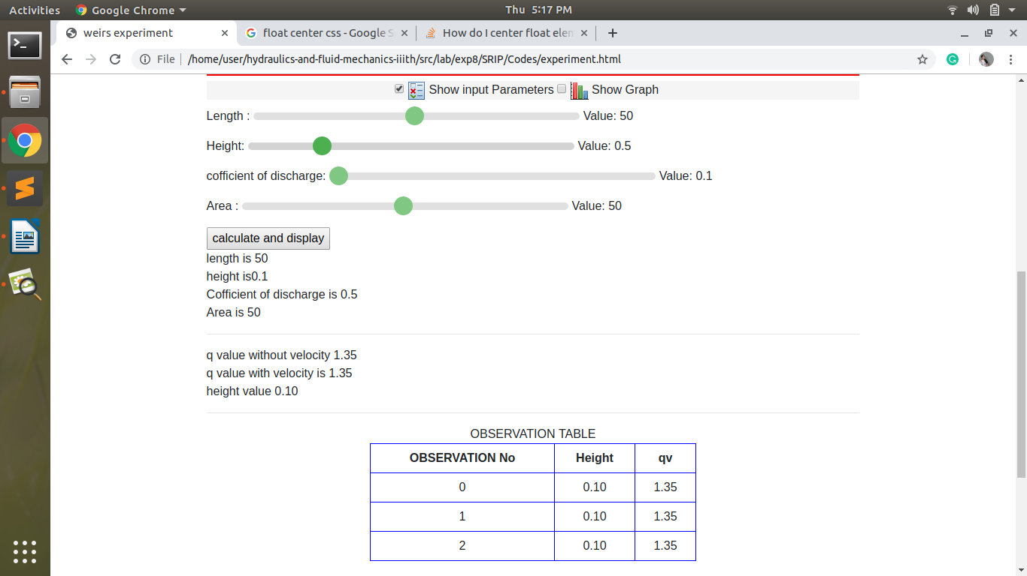“calculate and display” button (visible when checkbox “show input parameters” is enabled”) is to display input values, calculate and display output values,three observations can be taken and observation table is visible onclick button ”calculate and display”
3. “show graph” checkbox will display graph for calculated values(initialized with ZERO).